**Comparison between LLMs for knowledge graph creation**

Baseline Document

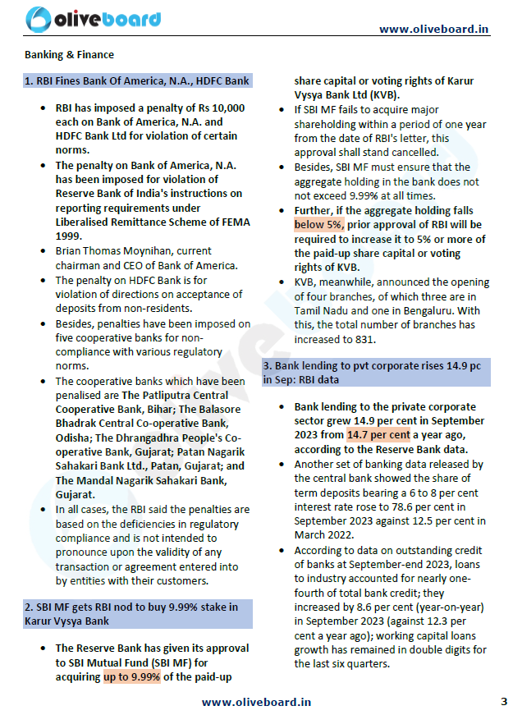

HUMAN INTERPRETATION

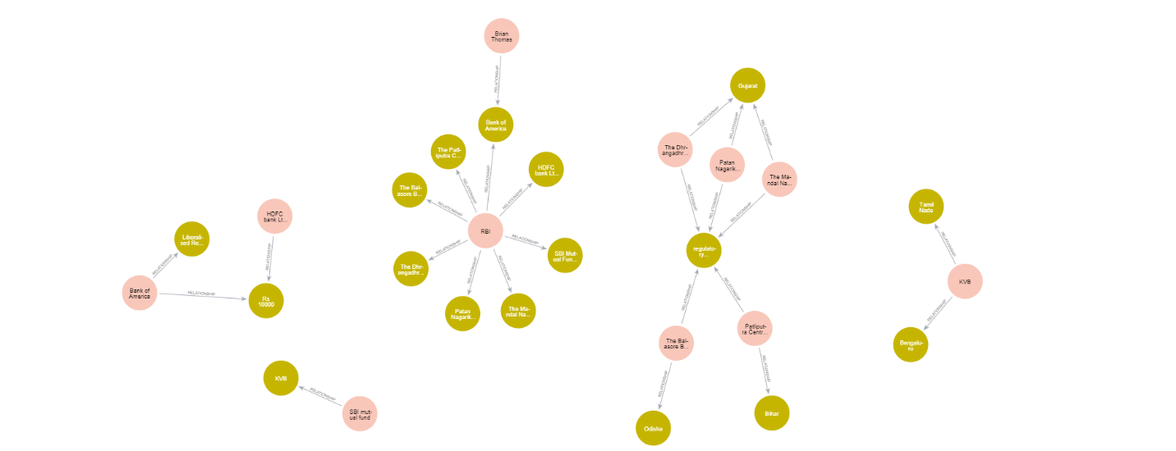

{

    "LLM": "Human Interpretaation",

    "File": "../data/December_2023_Bolt.pdf",

    "Processing Time": "",

    "Node count": 22,

    "Relation count": 25,

    "Nodes": [

        "RBI",

        "SBI Mutual Fund",

        "non-residents",

        "Karur Vysya Bank",

        "Hdfc Bank",

        "Bank of America",

        "Central Bank",

        "National stock exchange of India",

        "Interglobe Aviation",

        "Patliputra Central Cooperative Bank",

        "The Balasore Bhadrak Central Cooperative Bank",

        "The Dhrangadhra Cooperative Bank",

        "Patan Nagarik Sahakari Bank",

        "The Mondal Nagarik Sahakari Bank",

        "Liberalised Remittance Scheme of FEMA",

        "regulatory compliance",

        "Brian Thomas Moynihan",

        "Bihar",

        "Orissa",

        "Gujarat",

        "Tamil Nadu",

        "Bengalure"

    ],

    "Relations": [

        "imposed penalty on",

        "imposed penalty on",

        "imposed penalty on",

        "imposed penalty on",

        "imposed penalty on",

        "imposed penalty on",

        "imposed penalty on",

        "penalty of",

        "penalty of",

        "is Ceo/Chairman of",

        "Approves",

        "announced branch in",

        "announced branch in",

        "Intends to acquire",

        "violation of",

        "violation of",

        "violation of",

        "violation of",

        "violation of",

        "violation of",

        "located in",

        "located in",

        "located in",

        "located in",

        "located in"

    ]

}

GPT 3.5 Turbo-16K

{

    "LLM": "OpenAI-GPT-3.5-turbo-16k",

    "File": "../data/December_2023_Bolt.pdf",

    "Processing Time": "0:10:22.459900",

    "Node count": 28,

    "Relation count": 30,

    "Nodes": [

        "Branch3",

        "Patan Nagarik Sahakari Bank Ltd., Patan, Gujarat",

        "Karur Vysya Bank",

        "Central Bank",

        "Hdfc Bank",

        "Non-Residents",

        "The Balasore Bhadrak Central Co-Operative Bank, Odisha",

        "The Mandal Nagarik Sahakari Bank, Gujarat",

        "Industry",

        "Www.Oliveboard.In",

        "Cooperative Banks",

        "Total Bank Credit",

        "September 2023",

        "Working Capital Loans",

        "Kvb",

        "Deposits",

        "Sbi Mf",

        "Banks",

        "Rbi",

        "Branch1",

        "Branch2",

        "Bank Of America",

        "Outstanding Credit",

        "The Patliputra Central Cooperative Bank, Bihar",

        "Term Deposits",

        "March 2022",

        "Penalties",

        "The Dhrangadhra People'S Co-Operative Bank, Gujarat"

    ],

    "Relations": [

        "reportedBy",

        "reportedBy",

        "from",

        "imposed on",

        "penalized",

        "penalized",

        "penalized",

        "penalized",

        "penalized",

        "imposed by",

        "based on",

        "not intended to pronounce upon",

        "approval",

        "stake",

        "approval_required",

        "has_branch",

        "has_branch",

        "has_branch",

        "shows",

        "released in",

        "released in",

        "has",

        "data on",

        "at",

        "accounted for",

        "of",

        "at",

        "increased by",

        "in",

        "has remained"

    ]

}

GPT-4

{

    "LLM": "OpenAI-GPT-4",

    "File": "../data/December_2023_Bolt.pdf",

    "Processing Time": "0:05:46.850611",

    "Node count": 27,

    "Relation count": 21,

    "Nodes": [

        "Banking & Finance",

        "Transaction",

        "Centralbank",

        "Bank Of America, N.A.",

        "Thedhrangadhrapeoplescooperativebank",

        "Thepatliputracentralcooperativebank",

        "Deficienciesinregulatorycompliance",

        "Sbi Mutual Fund",

        "Termdeposits",

        "Nonresidents",

        "Workingcapitalloans",

        "Www.Oliveboard.In",

        "Themandalnagariksahakaribank",

        "Bengaluru",

        "Private Corporate Sector",

        "Brian Thomas Moynihan",

        "Penalties",

        "Fivecooperativebanks",

        "Kvb",

        "Hdfc Bank Ltd",

        "Rbi",

        "Patannagariksahakaribankltd",

        "Karur Vysya Bank Ltd",

        "Tamil Nadu",

        "Outstandingcredit",

        "Thebalasorebhadrakcentralcooperativebank",

        "Reserve Bank"

    ],

    "Relations": [

        "covers",

        "imposedPenalty",

        "imposedPenalty",

        "worksAt",

        "imposed",

        "appliedTo",

        "includes",

        "includes",

        "includes",

        "includes",

        "includes",

        "basedOn",

        "participatesIn",

        "approves",

        "involves",

        "regulates",

        "hasBranchIn",

        "hasBranchIn",

        "reportsGrowth",

        "releasedData",

        "releasedData"

    ]

}